|  |  |  |
| --- | --- | --- |
| YN Prevalence Sixty-seven percent of music students ages 7-17 reported playing related symptoms at some point, 56% reported them within the last month, and 30% reported an inability to play as usual within the last month. | |  | | --- | | **Transitions Physical Therapy**Playing Related Pain: What you need to Know |  Before and After Playing During Breaks |

For

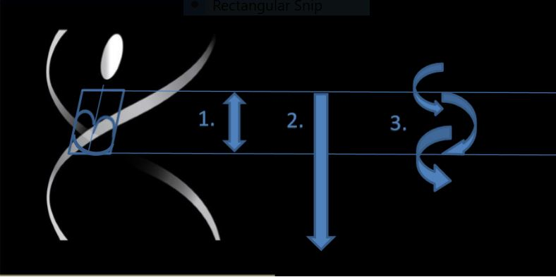

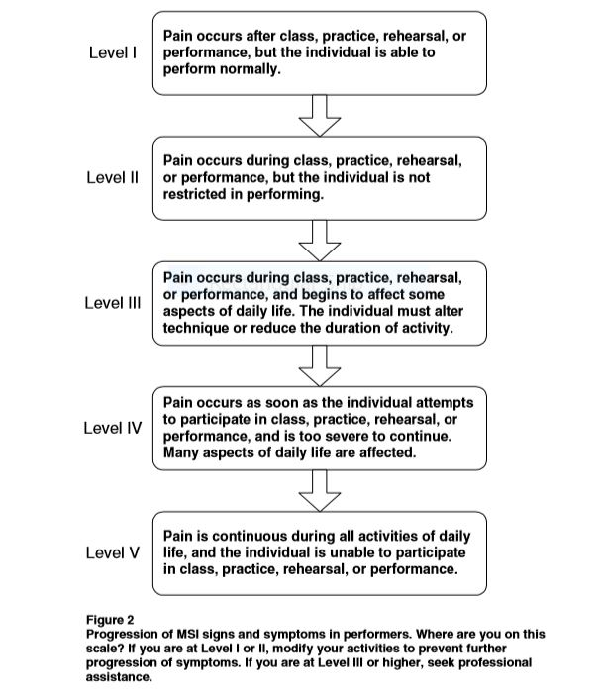The sooner You recognize a pain issue the better: Know this progression

*Students Starting to experience Level Three pain should consult with a performing arts specialist.*

*Musicians, receiving immediate and specific advice when to simply rest and self-manage a mild strain or when to consult a health professional for an injury is likely to be important for optimizing recovery and prevention. Chan et al. Frontiers in psychology 5 (2014): 706.*